Reflect on your relationships
This was originally created as an alternative to the standard ‘New Year’s Resolution’ process many of us go through at the end of one year and the beginning of the next. But this is an exercise you can do at any time during the year.

Read more about this exercise at: https://blogs.flinders.edu.au/student-health-and-well-being/2018/12/12/reflect-on-your-relationships/

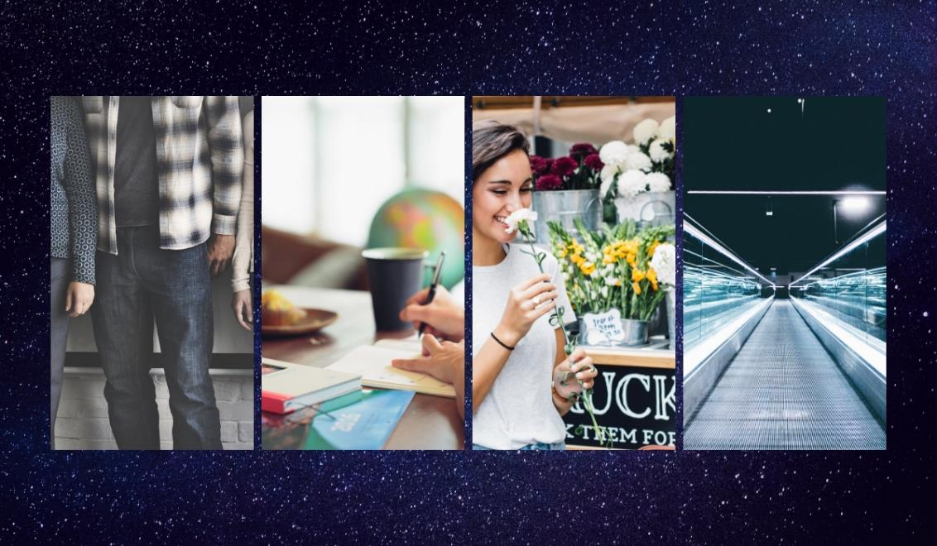
Start with the 3 most important people in your life.
 | Person……. | Person……. | Person …….
How do you feel about ...?
Are your feelings about ... consistent or do they change over time?
What do you like about ...?
What do you find challenging or difficult about ...?
How well does ... treat you?
What is it that ... needs from you?
When do you and .... work best together?
What are you grateful for in terms of ...?
Do you feel that overall your relationship with ... helps you or hinders you?
Moving forward do you still want to have a relationship with ... ?
What do you want the relationship with ... to be like?
What is 1 thing you could change in your own behaviour that might improve the relationship with ...?

Then consider the next 3 most important people in your life…..
 | Person……. | Person……. | Person …….
How do you feel about ...?
Are your feelings about ... consistent or do they change over time?
What do you like about ...?
What do you find challenging or difficult about ...?
How well does ... treat you?
What is it that ... needs from you?
When do you and .... work best together?
What are you grateful for in terms of ...?
Do you feel that overall your relationship with ... helps you or hinders you?
Moving forward do you still want to have a relationship with ... ?
What do you want the relationship with ... to be like?
What is 1 thing you could change in your own behaviour that might improve the relationship with ...?

Now consider how you feel about your work and study
 | Study……. | Work…….
How do you feel about ...?
Are your feelings about ... consistent or do they change over time?
What do you like about ...?
What do you find challenging or difficult about ...?
How well does ... treat you?
What is it that ... needs from you?
When do you and .... work best together?
What are you grateful for in terms of ...?
Do you feel that overall your relationship with ... helps you or hinders you?
Moving forward do you still want to have a relationship with ... ?
What do you want the relationship with ... to be like?
What is 1 thing you could change in your own behaviour that might improve the relationship with ...?

What about how you feel about your body and mind?
 | Body……. | Mind…….
How do you feel about ...?
Are your feelings about ... consistent or do they change over time?
What do you like about ...?
What do you find challenging or difficult about ...?
How well does ... treat you?
What is it that ... needs from you?
When do you and .... work best together?
What are you grateful for in terms of ...?
Do you feel that overall your relationship with ... helps you or hinders you?
Moving forward do you still want to have a relationship with ... ?
What do you want the relationship with ... to be like?
What is 1 thing you could change in your own behaviour that might improve the relationship with ...?

And finally, how do you feel about the world and your future?
 | The world……. | Your future…….
How do you feel about ...?
Are your feelings about ... consistent or do they change over time?
What do you like about ...?
What do you find challenging or difficult about ...?
How well does ... treat you?
What is it that ... needs from you?
When do you and .... work best together?
What are you grateful for in terms of ...?
Do you feel that overall your relationship with ... helps you or hinders you?
Moving forward do you still want to have a relationship with ... ?
What do you want the relationship with ... to be like?
What is 1 thing you could change in your own behaviour that might improve the relationship with ...?

